Empowering Individuals, Strengthening Families, Enriching Communities
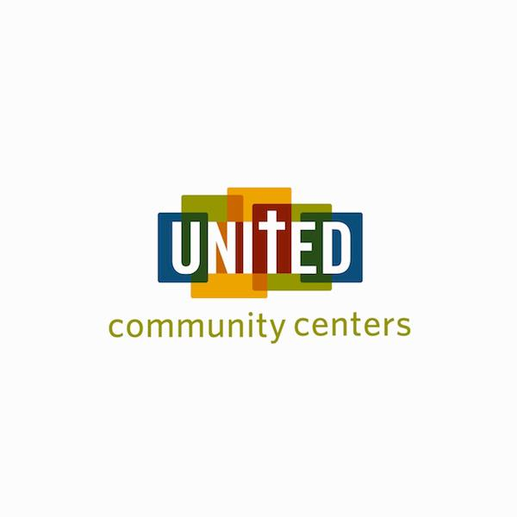

April 11 – May 2, 2021 | Collecting Change to Make a Change!  Help provide children in our community  with the basic academic building blocks  for success in school and in life  - reading, writing and comprehending  United Community Centers Ft Worth  Education Enrichment Programs

Empowering Individuals, Strengthening Families, Enriching Communities

April 11 – May 2, 2021 | Collecting Change  to Make a Change!  Help provide children in our community with the basic  academic building blocks  for success in school and in life  - reading, writing and comprehending  United Community Centers  Ft Worth  Education Enrichment Programs

